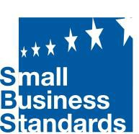

The European association supporting SMEs in standardisation

1. Why standards?

A standard is simply a set of commonly agreed criteria that allows what one business does to be in harmony with all other businesses in the same field. Standards are everywhere; they apply to all sorts of things, joining together goods, services and business practices in an invisible frame. Standards are the glue that holds the world together
– without them, everyday life would be very difficult indeed. Standardisation bridges research, innovation and the market. It also captures and disseminates knowledge and the state of the art, benefiting the whole economy.

Standards have been with us for centuries, and are so common we take them for granted. Yet today, in our fast-moving, technically complex and increasingly interconnected world, their importance is fundamental.

2. What standards do for SMEs?

Small and medium-sized enterprises (SMEs) is the one category which uses, needs and benefits from standards the most. SMEs benefit in myriad ways: costs are reduced when businesses have a set of agreed rules to work towards; goods and services can be marketed cross-border and internationally more easily and swiftly; and red tape is avoided as compliance to safety, functional and other requirements are built into production and supply processes. But many SMEs are either not aware of the standards which could help their businesses or of how best to use them. This is where Small Business Standards comes in.

3. Why Small Business Standards (SBS)?

Standards do not appear on their own – they have to be proposed, written, negotiated, agreed and rewritten to keep them up to date. SBS works with CEN, CENELEC and ETSI in Europe and ISO and IEC internationally to ensure that the small business community across Europe is properly represented throughout the world of standards.

SMEs across Europe

Some figures:

- > 20 million SMEs
- 93 million people employed
- 67% of all jobs
- 57% of the gross value added
- More than 1500 European standards delivered every year

“Without standards, there can be no improvement.”

So said Taiichi Ohno and he should know. Ohno developed the Toyota Production System, precursor to ‘just-in-time’ manufacturing, a process which has improved efficiency, saved costs and eliminated waste in manufacturing. The association supporting European across the world.

A deeper look at standards

Standards have many functions, from safety through staff management to helping computers talk to each other in the same language. They cover an astonishing range of goods and services from lifts to cosmetics, from quality management to cybersecurity, and from tattoo hygiene to water management. They define the safety of objects we use every day and make
life easier in a thousand ways. In this ever-evolving world, new standards are required and developed every year. And older standards may be revised or updated to ensure they are keeping pace with technological, societal and regulatory changes.

Stop and look, you can see standards everywhere

The standard screw head size, dating back to 1947, allows your screw driver to fit the screw;
A single agreed size for all payment cards allows you to withdraw money from ‘holes in the wall’ all over the world; A4, A5, A3 standards make paper, envelopes - and the hole in the postbox – the same size everywhere you travel; Material efficiency standards: expect more durability, reparability and recyclability of products; The railway track standard that allows trains to travel across borders; Agreed workplace requirements mean employers must always provide safety equipment for their staff; Standards for secure communication over the internet mean that SMEs can protect their customers’ data.

Standards:

- Bring reassurance for SMEs and consumers,
- Are a measure of good performance, efficiency and safety,
- Allow businesses to access the widest possible market.

Standards and SMEs – a perfect fit

Standards boost business.

The use of standards provides businesses with numerous advantages:

- Lower costs by minimising errors and reducing time to market;
- Consistent quality, which earns loyalty from customers and attracts new buyers;
- Goods or services allowed to move freely throughout the EEA;
- Compatibility and interoperability of products and processes;
- A ‘presumption of conformity’ with legislative and regulatory requirements;
- Enhanced trade by opening new market areas and facilitating market access;
- Access to the latest information and knowledge about new technologies, best practices and innovations.

Why SMEs need Small Business Standards

SMEs are a key part of the European economy; they create growth, employment and new jobs. In the EU’s private sector alone, SMEs account for two-thirds of all jobs. Yet SMEs often hesitate to take part in the standardisation process and their participation is low relative to their importance within the economy.

Together with craft companies, SMEs make up 99,8 % of all business in the EU and we believe that standards should be written with the small business in mind. Yet SMEs do not always have a strong enough voice in ensuring their needs are met. They do not always know which standards exist, how they would benefit from them or how to find out more. Some worry about potential costs and the difficulty of implementing standards; others believe standards only apply to large companies.

This can lead to a vicious circle: if SMEs do not participate in discussing, writing and updating standards, their needs will not be taken into account. The final standard might even place unnecessary or inappropriate requirements on them. Thus, SMEs see no benefit, they do not participate in standards development and the potential benefit for both small businesses and the economy as a whole is lost. Yet research clearly shows that using standards can substantially increase an SME’s turnover and contribute to increased productivity and GDP for a country. SBS is there to ensure that this potential is not lost. We at SBS are here to help SMEs throughout the standardisation process.

Join and influence: the role of SBS technical experts

SBS has approximately 70 qualified experts covering various key industry sectors.

These experts, annually appointed through an open call, represent European SMEs in more than 150 Technical Committees (TCs), Sub-Committees (SCs) and Working Groups (WGs), with a view to producing SME-compatible standards.

How does Small Business Standards help?

Small Business Standards gives SMEs in Europe the strong voice they need when it comes to standardisation, by ensuring their interests and needs are understood and safeguarded. Our guiding principle is think small first, because we believe that all standards should be developed with the interests of SMEs at heart.

We have three main goals:

• to represent the interests of SMEs in the standardisation process
• to raise their awareness about the benefits of standardisation
• to motivate them to engage in the standardisation process

SBS was established in 2013 as a response to the EU’s goal of making the standardisation system as inclusive, transparent and open as possible. SBS collaborates with sister bodies, such as trade unions (ETUC), consumer bodies (ANEC) and the environmental organisation (ECOS) to ensure that all the underrepresented interests are aligned at European level.
How SBS supports SMEs

- Monitoring and influencing standardisation

SBS contributes directly to the development of EU standards in a wide range of sectors such as textiles, construction, transport, ICT, tourism, electronic appliances, personal protective equipment, cosmetics, telecommunications and machinery. We work with 60 highly trained technical experts who sit in Technical Committees of the European Standards Organisations and in ISO and IEC. There, they directly influence standards to promote SME benefit. The technical experts appointed by SBS report back to us and we ensure the information flow to SMEs across Europe.

- Awareness-raising and training

SBS holds events and training seminars throughout the year, both at national and European
level. These are designed to inform trade associations, SMEs and other interested parties of the existence and the benefit of standards relevant to them.

- Contributing to EU standardisation policy and regulations

SBS was selected by the European Commission to officially represent SMEs in the European standardisation process. It therefore has a potent voice at political level in the EU, participating in EU level platforms and advocating on behalf of SMEs in the regulatory process. SBS has a seat on the managing bodies of CEN, CENELEC and ETSI, further extending its influence.

- Communication and news on standards

We at SBS know that communication is key. We keep SMEs up-to-date with regular reports, brochures and position papers, alongside press releases and monthly newsletters. We also run
workshops, seminars and conferences, all listed on our website (www.sbs-sme.eu).

- Looking out for the interests of SMEs

SBS regularly assesses the standards and best practices produced at European and international level to ensure they meet the needs of the SME community.

We always consult SMEs and SME associations when drafting position papers, in order to influence the direction of policy at EU level.

Join and influence: the role of SBS technical experts

SBS has around 70 qualified experts covering some 20 key industry sectors. These experts, annually appointed through an open call, represent European SMEs in more than 150 Technical Committees (TCs), Sub-Committees (SCs) and Working Groups (WGs), with a view to producing SME-compatible standards. ISO participation in Technical Committees, Sub-Committees and Working Groups; several liaison agreements are in place.

Key standardisation partners of SBS

- CEN and CENELEC
partnership agreements
www.cen.eu and www.cenelec.eu

- ETSI
membership
www.etsi.org

- ISO participation in Technical Committees, Sub-Committees and Working Groups; several liaison agreements are in place
www.iso.org

- IEC
Participation in several joint ISO/IEC JTCs
www.iec.ch

Where to find us ?

Rue Jacques de Lalaing 4
B-1040 Brussels
+32 (0)2 285 07 27
info@sbs-sme.eu

Transparency Register 653009713663-08

Co-financed by the European Commission and EFTA
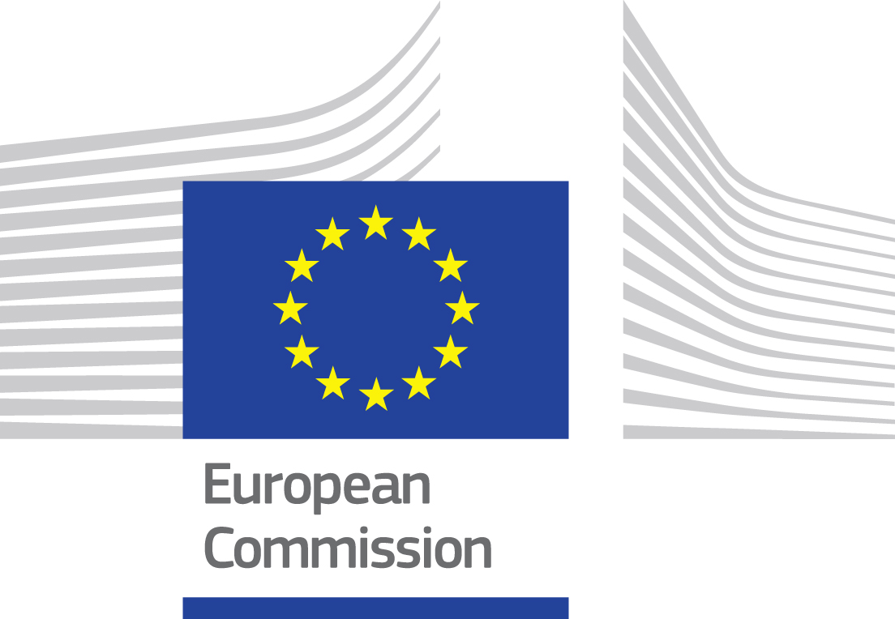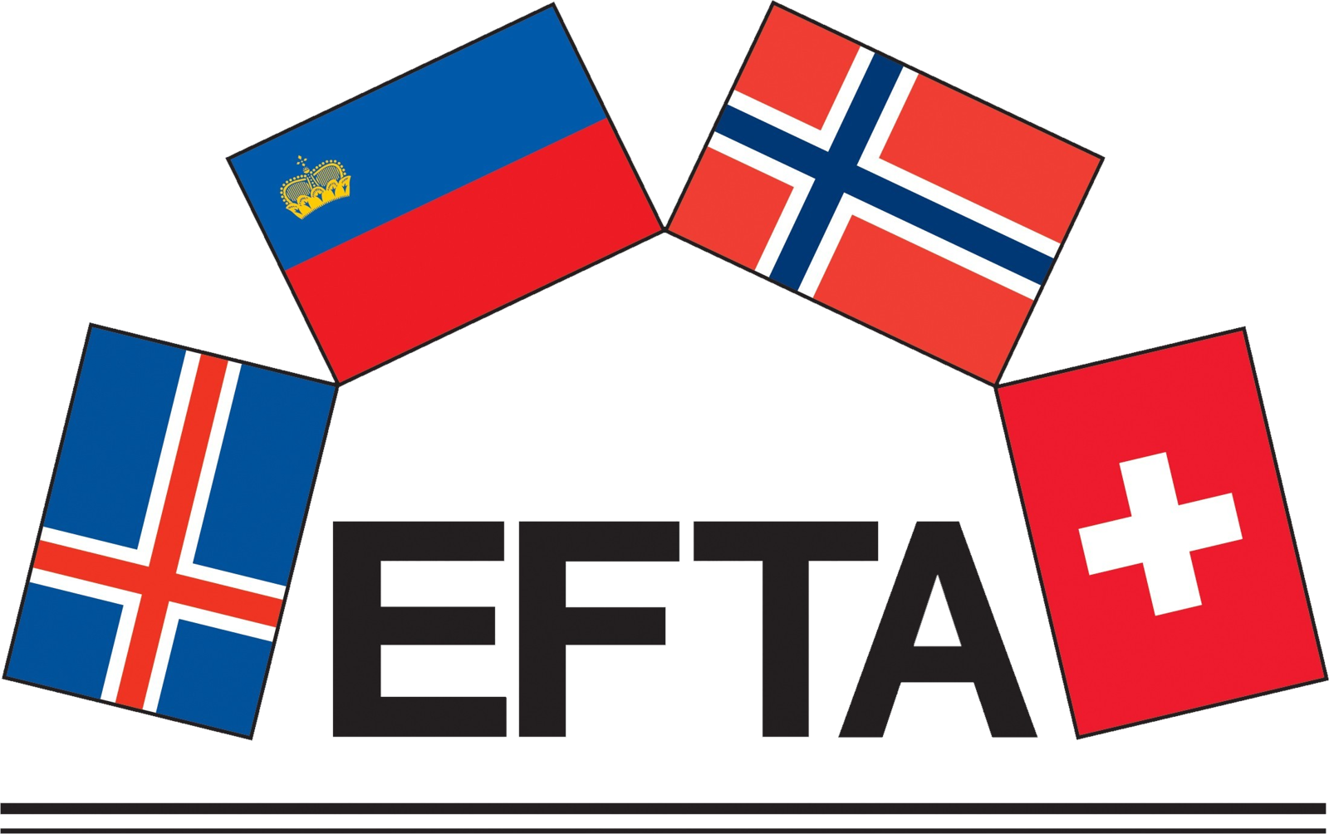

This brochure only reflects Small Business Standards’ views. The European Commission and the EFTA Member States are not responsible for any use that may be made of the information it contains.

